Protecting your devices and network

Protecting your computing devices

**Your pc devices are the portal to your online life, storing a lot of your personal data**

**Therefore. Its important to protect the security of you devices**

- turn the firewall on

- **You should set up at least one type of firewall** (either software or hardware firewall)

- The firewall should be turned on and constantly updated to prevent hackers from accessing

your personal or organizational data

- install antivirus and antispyware

- to prevent this, you should only ever download software from trusted websites

- but you should always use antivirus software to provide another layer of protection

- manage your operating system and browser

- you should **set up the security settings on you computer and browser to medium lever or**

**Higher**

- **regularly update your computer**s operating system, including your web browser and

download the latest software patches and security updates from the vendors

- set up password protection

- **all your devices should have a password to prevent unauthorized access**

- **sensitive data should be encrypted**

Wireless network security at home

Hackers will be aware of the **PRESET SSID and default password** (of rooter) therefore it

**should be changed**

Further more you should encrypt wireless communication by **enabling wireless security and**

**the WPA2 encryption feature**

hackers can attacks with reinstallation attacks or (KRACKs) (breaking the encryption)

To mitigate this you should:  
 - update wireless capable devices

- Use wired connection for any device capable of it

- Use trusted virtual private network (VPN)

Public wi-fi risks

First of all you should always verify that your device isnt configured with file and media

sharing and that it requires user authentication with encryption

Ale use encrypted VPN

Strong password

**Do not use dictionary words or names in any language**

**Do not use common misspellings of dictionary words**

**If possible use special characters [($%#@!^&*()-…..)](mailto:($%#@!^&*()-…..))**

**Do not use computer names or account names**

**Use a password with more than ten characters**

Using a passphrase

Passphrase generally takes the form of a sentence (‘Acat [th@tlov3sd0gs.’)](mailto:th@tlov3sd0gs.’))

Making it easier for you to remember and its longer then typical password

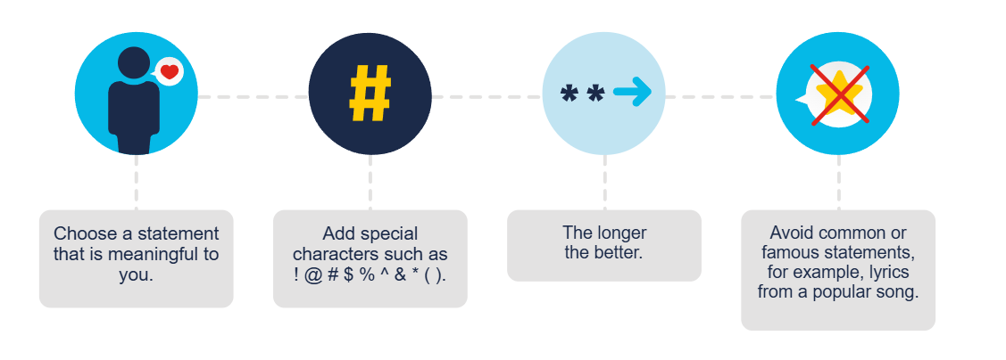

Password guidelines

- Password should be at least 8 characters long but no longer than 64

- Common easily guessed passwords such as ‘password’ should be avoided

- Composition rules, such as having lower and uppercase letters and numbers

- Users should be able to see the password to improve accuracy

- All printing characters and spaces should be allowed

- No password hints

- No password expiration period

- No knowledge-based authorization, such as having to provide answers to secret questions

or verify transaction history